**Bài test buổi thứ 13**

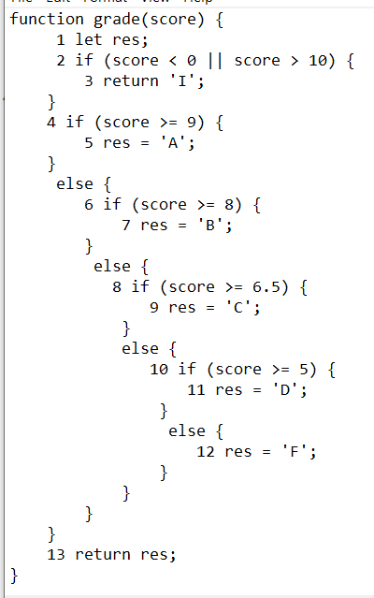

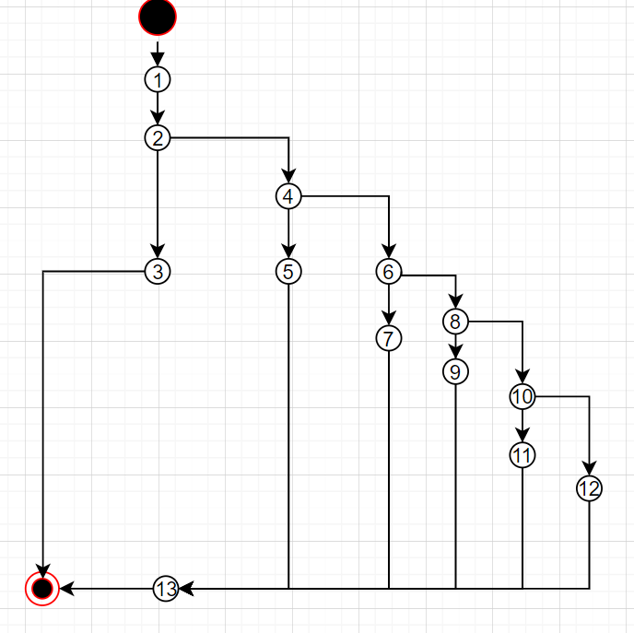

TH score < 0 hoặc score > 10

1 – 2 – 3

TH nếu 9 <= score <= 10

1 – 2 – 4 - 5 - 13

TH nếu 8 <= score < 9

1 – 2 - 4 – 6 – 7– 13

TH nếu 6.5 <= score <= 8

1 – 2 – 4 – 6 – 8 – 9 - 13

TH nếu 5 <= score <= 6.5

1 – 2 – 4 – 6 – 8 – 10 – 11 – 13

TH nếu 0 <= score <= 5

1 – 2 – 4 – 6 - 8 – 10 – 12 - 13